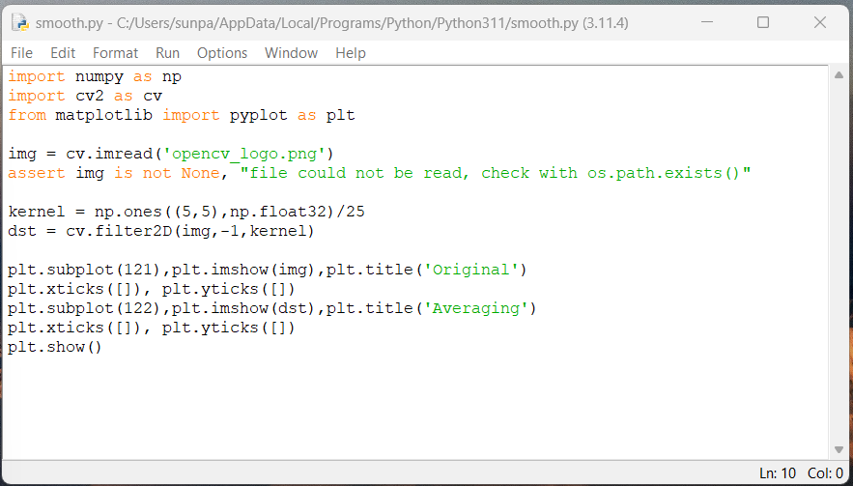

Code to smooth kernels of size n by n with a matrix of all ones divided by n^2 which is 25

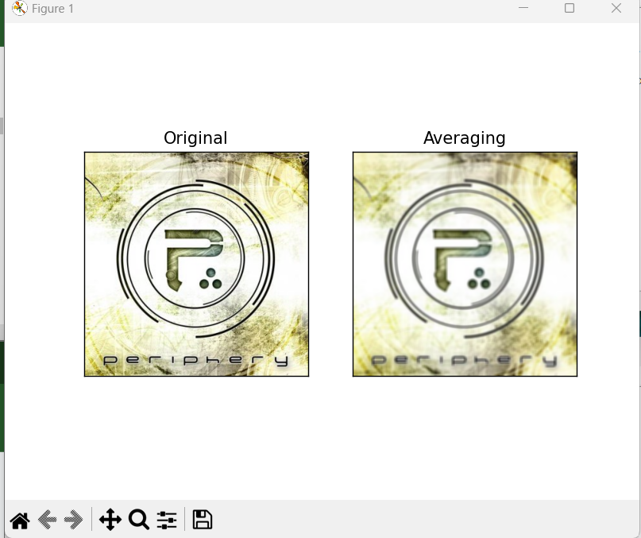

Results

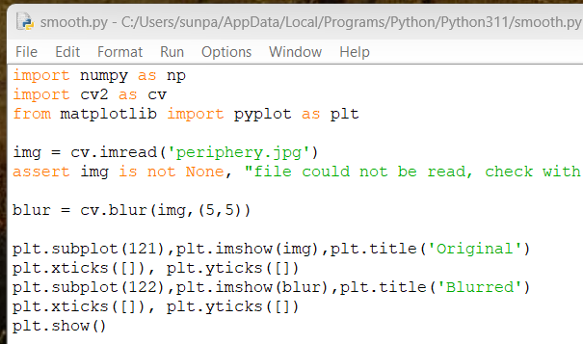

Smoothing using built in blur function

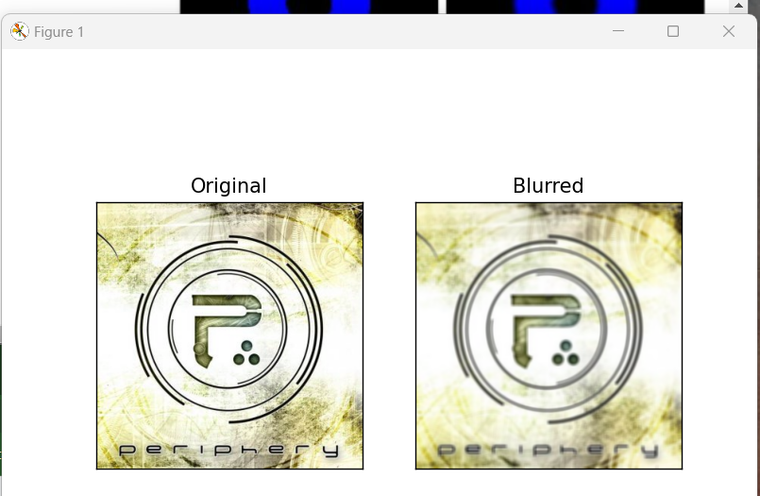

Similar output



Using gaussian blur

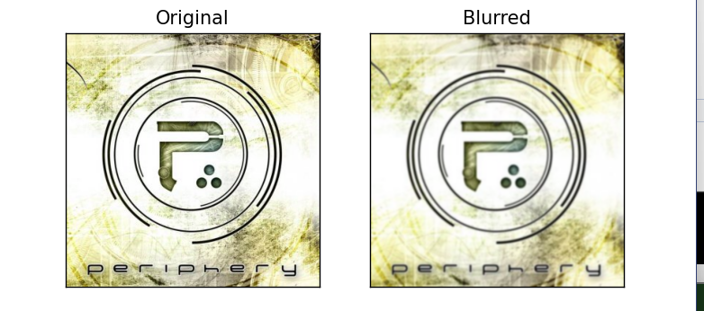

Similar output

Median blur

[cv.medianBlur](https://docs.opencv.org/3.4/d4/d86/group__imgproc__filter.html#ga564869aa33e58769b4469101aac458f9)(img,5)



Irregularities from kernel size are more noticeable

Bilateral Blur, blur based on differences in pixel intensity and distance





Strong edges and values are preserved, background noise and noise within regions of similar value are smoothened